**Software Requirement Specification**

**January 18, 2018**

**COLLEGE BOT**

**Anand S**

**Arul Kumar T**

**Divya U**

**Mohamed Sharuk CM**

**ARITIFICIAL INTELLIGENCE AND CHATBOT**

**Artificial Intelligence:**

Artificial intelligence (AI) is an area of computer science that emphasizes the creation of intelligent machines that work and react like humans.

**Chatbot**

Chat bots are computer programs that mimic conversation with people using artificial intelligence. They can transform the way you interact with the internet from a series of self-initiated tasks to a quasi-conversation.

**Machine Learning Tools:**

1. Amazon SageMaker
2. Amazon API services
3. Amazon's Deep Scalable Sparse Tensor Network Engine (DSSTNE)
4. Azure Machine Learning workbench
5. Azure Machine Learning Model Management
6. **Google TensorFlow**
7. Google APIs
8. Microsoft Distributed Machine Learning Toolkit (DMLT)
9. Microsoft Computational Network Toolkit (CNTK)
10. IBM Watson Analytics
11. BigML
12. Apache Spark MLlib and Singa
13. Veles
14. Alibaba’s Aliyun
15. Caffe
16. Neon
17. Wise.io

**College Bot:**

The College bot is built using artificial intelligence that analyses user’s queries and understand user’s message. Students and parents just have to query through the bot by chatting. Students can chat using text format. The System uses built in artificial intelligence to answer the query. The system provides answers as per user queries. The System analyses the question and then answers to the user. The user can query about admissions and its details. This system also helps the student to be updated about the college activities.

An example of typical input would be something like this:

User: Courses that are available in your college

Bot: Computer Science and Engineering

Information Technology

Electronics and Communication Engineering

Mechanical Engineering

Civil Engineering

**MINIMUM SYSTEM REQUIREMENTS**

**Hardware Requirements:**

Processor : Intel i3

Memory : 4GB RAM

**Software Requrements:**

Operating System : Windows 7

Coding Language : Python

ToolKit : Anaconda Navigator, Jupiter Notebook, Command Prompt

**Process Flow:**

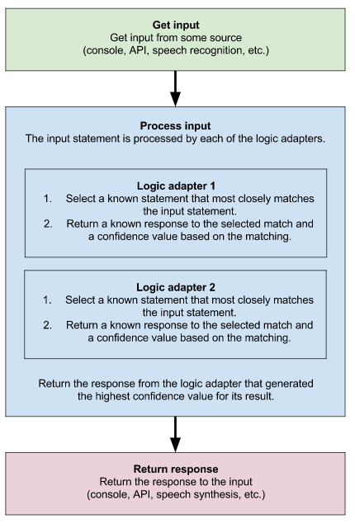

**Installation of TensorFlow in Anaconda**

Following are the steps to install tensorflow in anaconda environment

1.Open Command Prompt.

2. Create a conda environment named tensorflow by invoking the following command:

C:> **conda create -n tensorflow python=3.5**

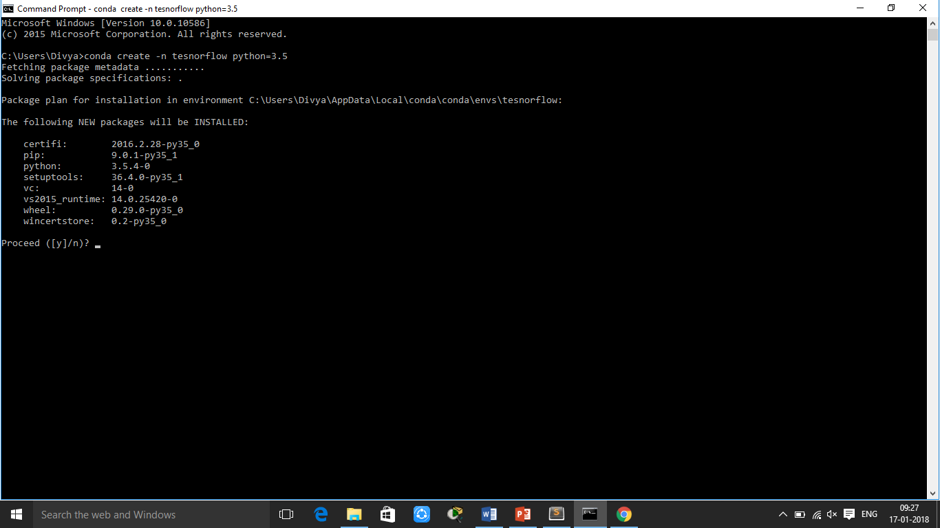

3. Activate the conda environment by issuing the following command:

C:> **activate tensorflow**

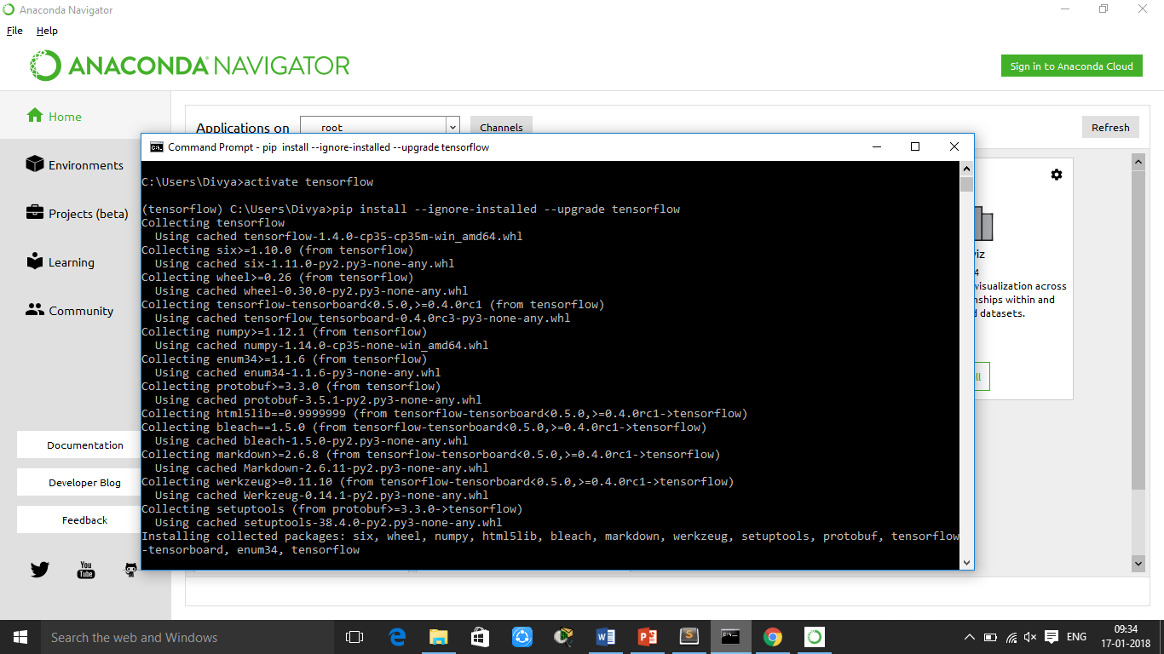

(tensorflow)C:> # Your prompt should change

4. Issue the appropriate command to install TensorFlow inside your conda environment. To install the CPU-only version of TensorFlow, enter the following command:

(tensorflow)C:> **pip install --ignore-installed --upgrade tensorflow**

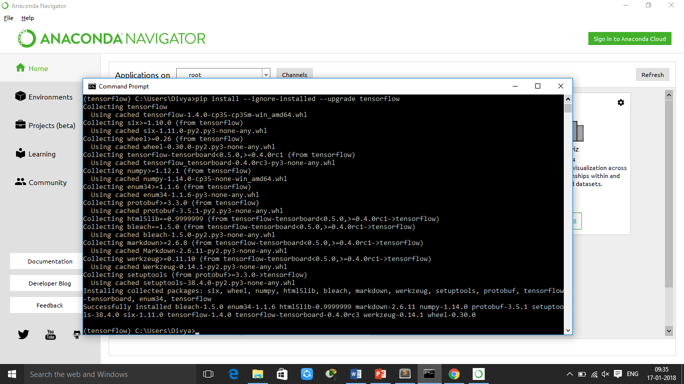

5. To install the GPU version of TensorFlow, enter the following command

(tensorflow)C:> **pip install --ignore-installed --upgrade tensorflow-gpu**

